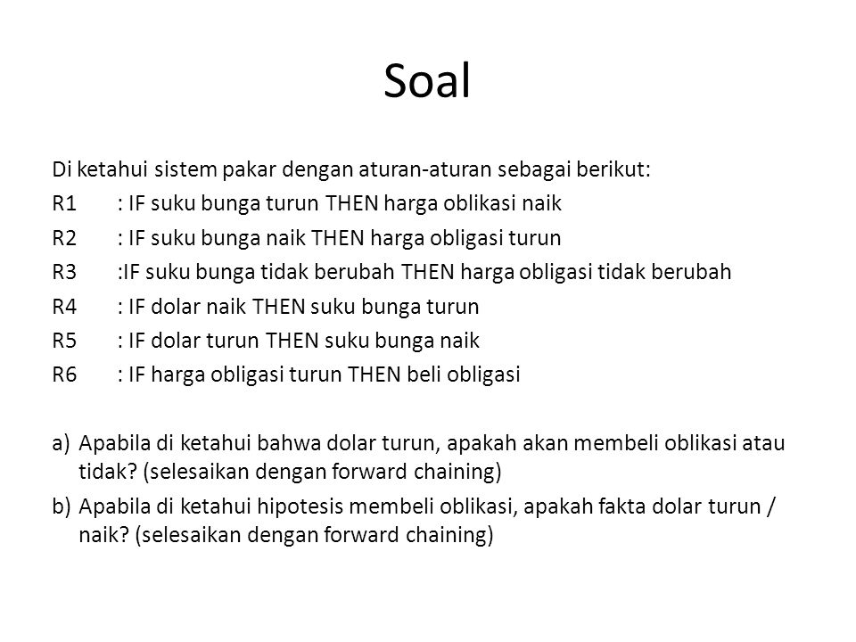

Suku bunga turun ; 2

Harga oblikasi naik ; 3

Suku bunga naik ; 4

Harga obligasi turun ; C

Suku bunga tidak berubah ; 1

Harga obligasi tidak berubah ; 0

Dolar naik ; 5

Dolar turun ; D

Beli obligasi ; A

~~R1 : IF 2 3~~

~~R2: IF 4 C~~

R3: IF 1 0

~~R4: IF 5 2~~

~~R5: IF D 4~~

~~R6: IF C A~~

1. Fakta = D

Goal = A

Data base

3 , 2,4,0 3,C,2,4, **A**

~~R1 : IF 2 3~~

~~R2: IF 4 C~~

~~R3: IF 1 0~~

~~R4: IF 5 2~~

R5: IF D 4

~~R6: IF C A~~

1. Fakta = 5

Goal = A

Data base

2,1,C 3,4,0,5, **A**